**ICS2O/3C Midterm Part 2 – Short Answer Name:**

**Short Answer Questions Guidelines**

· Answer each question in the spaces below

· Clearly identify each of the points you are answering

· Provide a complete sentence for each point with clear details and justification.

· Each question is worth 5 marks

· The total for this summative is 35 marks

**Short Answer Questions**

1. Describe a specific hardware component that is found inside a PC tower case. Include the following points in your answer:

a. The name of the component

b. The main function of the component

c. Some important features of the component

d. Where the component is located inside the PC tower case

e. How the component has changed since the 1990s with respect to speed

f. How the component has changed since the 1990s with respect to size (e.g. megabytes)

1. Sound & Audio: sound cards.
2. “A device that can be slotted into a computer to allow the use of audio components for multimedia applications”—Wikipedia. An expansion card for creating sound heard through headphones or speakers. Is not mandatory for a PC to function, but adds to the experience onscreen. Bundled in with every PC either in PCI slots or included via the motherboard. Initially consisted of one beep that could be altered in pitch and duration.
3. Utilizes automated pulses depicting 0s and 1s (binary code). Transcribes the computer’s binary data and the external input of analog information. Manipulates four components to decipher analog and digital information:
   1. An analog-to-digital converter (ADC).
   2. A digital-to-analog converter (DAC).
   3. An ISA (Industry Standard Architecture which is part of a computer that pertains to programming, basically machine language.) or PCI interface to connect the card to the motherboard.
   4. Input and output connections for a microphone and speakers. Cipher/decipher chip called a CODEC performs both ADC and DAC conversions.
4. 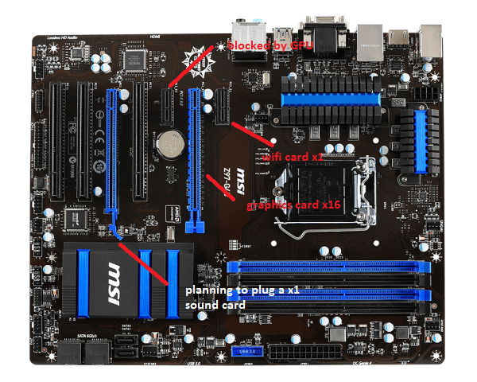
5. Before the days of dedicated hardware specifically aimed towards audio enhancements, the PC could naturally make one distinct tone: a beep. Though the pulsation and span of said beep could be altered and tweaked, the amplification of the sound couldn’t be changed. There weren’t options for more diversified tones either. Initially, the beep was used as an indicator or cautioning device. Afterward however, developers found a way to harness and utilize the beeps, constructing music from it using different harmonic tones and durations. This newform expression of music is called, “chiptune” (which is actually one of my favourite genres of music). Technological effectiveness expanded exponentially in the 1980s, when computer producers brought into light addons that were designed to regulate sound. Luckily in today’s day and age, we aren’t stuck with the fascinating, yet still limiting hardware that chiptune is based off of. Nowadays, sound cards are capable of producing 3D audio for games or enveloping sonorousness reciprocation for DVDs.
6. At a relatively inexpensive price, the Asus Xonar DSX PCIe 7.1 sound card is perfect for both movies and games. Plugging directly into the PCIe x1 slot that works with the newest motherboards, the Xonar’s support for 7.1 surround sound is matched by added support for its swapped OP-AMP. The “operational amplifier” assists in signal amplification, so it can produce a powerful output signal and thereby provide better sound. Beyond swappable components, the Xonar works to bring hi-fi theater directly to your desktop with support for DTS Connect, which assists in boosting overall sound quality. The introduction of Xonar’s GX2.5 audio engine adds an outstanding depth of sound for a truly immersive gaming experience. Additionally, the Xonar’s 192K/24bit support minimizes signal-to-noise and allows the focus to be solely on gaming or multimedia performance. Kick EAX into gear for older games and you’ll find an equally high-quality sound that’s comparable to 4K televisions upscaling older movies to HD for the best possible entertainment experience.

2. Describe a specific hardware component that is found outside a PC tower case. Include the following points in your answer:

a. The name of the component

b. The main function of the component

c. Some important features of the component

d. Where the component is located inside the PC tower case

e. How the component has changed since the 1990s with respect to speed

f. How the component has changed since the 1990s with respect to size (e.g. megabytes)

1. Hard Drives.
2. The hard drive is what stores all your data. It houses the hard disk, where all your files and folders are physically located.
3. HUnlike volatile storage like [RAM](https://www.lifewire.com/what-is-random-access-memory-ram-2618159), a hard drive keeps a hold of its data even when powered off. This is why you can [restart a computer](https://www.lifewire.com/how-to-reboot-a-computer-2624568), which powers down the HDD, but still have access to all the data when it's back on.
4. 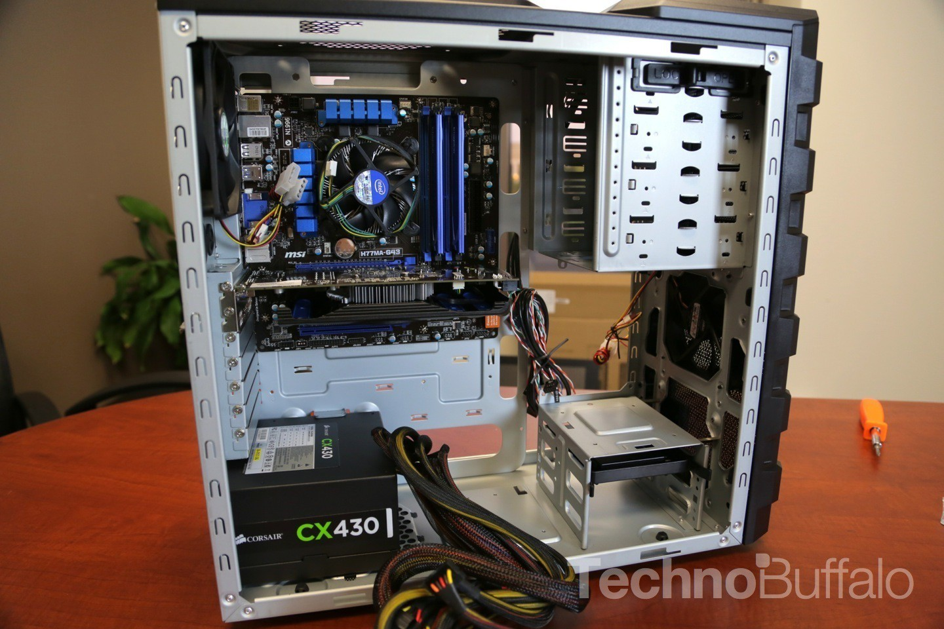
5. The first production IBM hard disk drive, the 350 disk storage, shipped in 1957 as a component of the IBM 305 RAMAC system. It was approximately the size of two medium-sized refrigerators and stored five million six-bit characters (3.75 megabytes)[13] on a stack of 50 disks.
6. A typical hard drive is only slightly larger than your hand, yet can hold over 100 GB of data. The data is stored on a stack of disks that are mounted inside a solid encasement. These disks spin extremely fast (typically at either 5400 or 7200 RPM) so that data can be accessed immediately from anywhere on the drive.

3. Describe a specific computer malware (e.g. worm, virus, trojan, etc.). Include the following points in your answer:

a. The name of the malware

b. The type of malware (justify your answer)

c. The visible signs on a computer that is infected

d. Ways to prevent or remove the attack

e. Its impact on a single user / computer

f. Its impact on society / the economy

1. WannaCry Ransomware.
2. A computer worm is an individual malware program that duplicates itself to be able to spread to and from computers.Worms deal at least some sort of damage, even if it’s just exhausting bandwidth (the range of frequencies within a given band, in particular that used for transmitting a signal).
3. It arrives on the infected computer in the form of a *dropper,* a self-contained program that extracts the other application components embedded within itself. Those components include:

* An application that encrypts and decrypts data
* Files containing encryption keys
* A copy of Tor

The program code is not complicated and was relatively easy for security pros to analyze. Once launched, WannaCry tries to access a hard-coded URL (the so-called *kill switch*); if it can't, it proceeds to search for and encrypt files in a slew of important formats, ranging from Microsoft Office files to MP3s and MKVs, leaving them inaccessible to the user. It then displays a ransom notice, demanding $300 in Bitcoin to decrypt the files.

1. The vulnerability WannaCry exploits lies in the Windows implementation of the Server Message Block (SMB) protocol. The SMB protocol helps various nodes on a network communicate, and Microsoft's implementation could be tricked by specially crafted packets into executing arbitrary code. Ironically, the patch needed to prevent WannaCry infections was actually available before the attack began: Microsoft Security Bulletin MS17-010, released on March 14, 2017, updated the Windows implementation of the SMB protocol to prevent infection via EternalBlue. However, despite the fact that Microsoft had flagged the patch as critical, many systems were still unpatched as of May of 2017 when WannaCry began its rapid spread.
2. After infecting a Windows computers, it encrypts files on the PC's hard drive, making them impossible for users to access, then demands a ransom payment in bitcoin in order to decrypt them.
3. It struck a number of important and high-profile systems, including many in Britain's National Health Service; it exploited a Windows vulnerability that was suspected to have been first discovered by the United States National Security Agency; and it was tentatively linked by Symantec and other security researchers to the Lazarus Group, a cybercrime organization that may be connected to the North Korean government. Economic costs in the hypothetical cloud provider attack dwarf the **$8 billion** global cost of the “WannaCry” ransomware attack in May, which spread to more than 100 countries

4. Describe a specific equity issue discussed in class (e.g. Emoji Equity). Include the following points in your answer:

a. The types of groups affected (e.g. Gender, Race, Religion, etc.).

b. For each affected group, explain how they are affected with specific details

c. Explain how the software or applications do not currently provide equity

d. Explain how developers of the software or applications plan to make improvements regarding equity

1. People in the LGBTQ+ community often feel as though they’re not represented enough due to the lack of things such as a pride flag, emojis of samesex and interracial couples, etc. People who are disabled don’t feel as though they are accurately portrayed with the copious amount of disabilities out there. On iOS, there is only a wheelchair user sign.
2. But based on the amount of public pressure for greater emoji diversity, it's clear many people believe this is a serious matter. In April 2015, Apple introduced emoji with different skin tones for the iPhone following criticism from users that the characters depicting people were too white. Before the Apple update, there were only two visibly diverse emoji: a brown man wearing a turban and an Asian man wearing a cap. Now, iPhone users have the option to choose between six different skin-tone modifiers for various emoji characters. ​Same-sex families were also added to Apple's emoji update.

1. Scope, a UK-based disability charity, released 18 emoji designs representing people with disabilities and Paralympic sports. Currently, the only emoji to represent disabilities is the wheelchair user sign. "All the emotion emojis, for instance, can carry different implications in different cultures and within different contexts within a culture," says Boyd. Emojis lack precision, "which limits their communicative efficacy." Even though emoji - or their predecessors, emoticons - might have originally been intended to help clarify the author's meaning, they're also open to wide interpretation based on the context of their use, variance in graphical representations and technical issues, all of which can influence how the meaning of messages is perceived by others.
2. The latest push for emoji equality comes from Google. The internet giant recently announced it will introduce several new emoji to represent women working diverse careers.A female doctor, scientist, welder and mechanic are just a few of the new images. The new professional emoji will be available in a variety of skin tones and in male versions, too. However, it is still not known when these emoji will be available on devices. Unicode will also add male and female versions of 33 existing emoji.

5. Describe social and environmental issues related to cryptocurrencies such as Bitcoin and Bitcoin mining. Include the following points in your answer:

a. List and explain some concerns for society related to this technology

b. Explain how to minimize these social concerns through responsible use.

c. List and explain some concerns for the environment related to this technology

d. Explain how to minimize these environmental concerns through responsible use.

1. Each transaction is associated with the sender's and receiver's bitcoin wallet address. And anyone who wants to convert bitcoins into dollars, to facilitate spending in the real world, will need eventually to perform a transaction that associates their cryptocurrency wallet with their bank account (and personal identity). Additionally, regulatory agencies have begun demanding data from cryptocurrency exchanges in an effort to identify money launderers and tax evaders.
2. To minimize social concerns, bitcoin should only be something you do on the side rather than go all in on, risking your security. Means of buying things through the use of cash, credit and debit cards should take priority due to how we as a society have been able to further flesh out and take advantage of the technology. Bitcoin is very new to us and as such we need to think more methodically rather than impulsively even though it’s the hottest thing on the market.
3. **Bitcoin mining** is the process by which transactions are verified and added to the public ledger, known as the blockchain, and also the means through which new **bitcoin** are released. ... The **mining** process involves compiling recent transactions into blocks and trying to solve a computationally difficult puzzle. Toronto-based Hut 8 has spent more than $100 million to develop the 4½-hectare site on the northern edge of the city. It has 56 shipping containers, each filled with 180 computer servers that digitally mine for bitcoin around the clock. The bitcoin mining facility is located right beside the city of Medicine Hat's new natural gas-fired power plant and four wind turbines are a short distance away. The bitcoin plant can consume more than 60 megawatts of power, more than 10 times more electricity used by any other facility in the city, according to the mayor. The vast amount of electricity needed for bitcoin mining is why the city of Medicine Hat has championed the economic benefits of the project. Environmental groups are concerned by the sheer amount of energy consumed by bitcoin mining, especially in places like Medicine Hat where most of the electricity is produced by fossil fuels.
4. To minimize these environmental concerns, there could be a small plot of land dedicated to bitcoin mining. The controversy surrounding Medicine Hat is the result of going all in on bitcoin as if it’s the future of payment. The act seemed rather impulsive, and as such a compromise should be put in place to satiate the needs of those who need their bitcoin fix, and those who want to protect the environment as much as possible.

6. Discuss the function and features of Privacy Policies and Terms of Service Agreements found for most on-line services such as GitHub. Include the following points in your answer:

a. Explain the main features of and the reason for a Privacy Policy

b. Explain the main features of and the reason for a Terms of Service Agreement

c. Explain the main difference between a Privacy Policy and a Terms of Service Agreement

d. Explain some of the identity and personal information you give away when using these services

e. Explain some things you can do to limit how much identity and personal information you give away

1. The contents of a Privacy Policy may differ from one country to another, depending on the country legislation, but most privacy laws identify the following critical points that a business must comply with when dealing with personal data: **Notice**. Data collectors (meaning, you or your company) must make clear what they are doing with the personal information from users before gathering it. **Choice**. The companies collecting the data must respect the choices of users on what information to provide and how personal that provided information will be. **Access**. Users should be able to view or contest the accuracy of personal data collected by the company. **Security**. The companies are entirely responsible for the accuracy and security (keeping it properly away from unauthorized eyes and hands) of the collected personal information. This means that a “Privacy Policy” serves as a way to inform users how their personal information will be used, along with how the information will be collected and who has access to it.
2. A Terms and Conditions agreement (T&C), but also known as a Terms of Service or Terms of Use agreement, is the legal agreement that sets forth the rules, requirements, and standards of using a website or a mobile/desktop app. A Terms and Conditions is not required by law, unlike a Privacy Policy, but it’s highly recommended to have one as you can prevent abuses happening to your website or mobile app, and to [limit your own liability](https://termsfeed.com/blog/draft-limitation-exclusion-liability-clauses/) as the owner of the online business. Without this kind of agreement in place, and without it being properly enforced, there’s no way for you can legally limit or control how anyone can use or can’t use your website or app. Issues of copyright infringement can appear if users make use of your content without your permission or issues of abuses such as someone spamming other users or posting defamatory content on your website. A Terms & Conditions agreement lets you include language to forbid such activity, and can also provide a remedy (such as accounts deletion) in the event these abuses do occur.
3. A Terms and Conditions agreement (T&C), but also known as a Terms of Service or Terms of Use agreement, is the legal agreement that sets forth the rules, requirements, and standards of using a website or a mobile/desktop app. A Terms and Conditions is not required by law, unlike a Privacy Policy, but it’s highly recommended to have one as you can prevent abuses happening to your website or mobile app, and to [limit your own liability](https://termsfeed.com/blog/draft-limitation-exclusion-liability-clauses/) as the owner of the online business. The contents of a Privacy Policy may differ from one country to another, depending on the country legislation, but most privacy laws identify the following critical points that a business must comply with when dealing with personal data:
4. · **Notice**. Data collectors (meaning, you or your company) must make clear what they are doing with the personal information from users before gathering it.
5. · **Choice**. The companies collecting the data must respect the choices of users on what information to provide and how personal that provided information will be.
6. · **Access**. Users should be able to view or contest the accuracy of personal data collected by the company.
7. · **Security**. The companies are entirely responsible for the accuracy and security (keeping it properly away from unauthorized eyes and hands) of the collected personal information.
8. This means that a “Privacy Policy” serves as a way to inform users how their personal information will be used, along with how the information will be collected and who has access to it.

7. Discuss the function and features of computer software development sites such as GitHub and repl.it. Include the following points in your answer:

a. Provide specific examples and an explanation of how to use folders to organize your work files

b. Provide specific examples and an explanation of how to use meaningful names for folders and work files

c. Provide specific examples and an explanation of how to use these services to share work between your home and school environments.

d. Provide specific examples and an explanation of how to use these services to share work between different users.

1. To make your own folder, you click on “Create new file”, type in the name of the directory you want to create and then the name of the folder.
2. For example, I created a repository specifically dedicated to computer science work. From there, I made the amount of files I needed in order to neatly organize my work. In the folders are word documents of my answers to assigned work.
3. Specifically for me, I download the work from Mr. Nestor’s repository, open it in Word, then copy and paste the information to Google Docs for easy of using.
4. From Google Docs, I type in all my answers in the provided space below and click the share button. I then select Mr. Nestor’s name in order for him to view it, then download the document as a Word document, uploading it to my repository.